**D. Y. Patil College of College of Engineering and Technology, Kolhapur**

**Department of Computer Science & Engineering**

**Class: SY-A Subject: AOOC**

**Experiment no: 15**

**Group No. G31 Mini Project**

**Title of Mini-Project: Employee Payroll System**

**Problem Statement:**

**Design and develop an Employee Payroll System that helps manage employee details, calculate monthly salaries, generate payslips, and keep records of attendance, bonuses, and deductions in an easy and efficient way.**

**Introduction:**

**The Employee Payroll System is a simple tool that helps companies manage their workers' salary details. It saves employee data, tracks attendance, calculates monthly pay, and creates salary slips. This system makes the work faster, easier, and more accurate for the company.**

**System Architecture:**

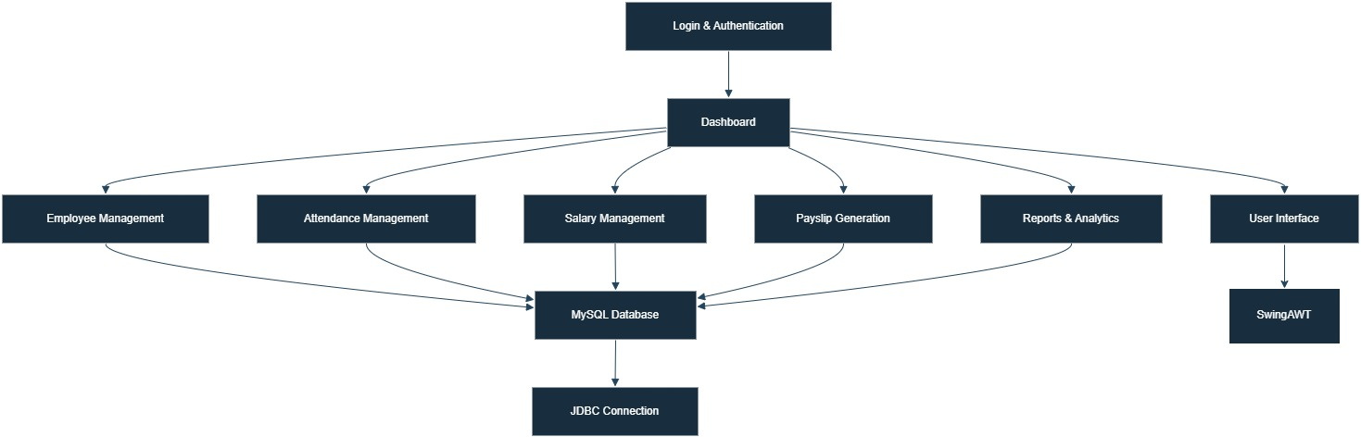

**Module description or working of system:**

**Login & Authentication**

**– The system starts with a login screen built using Swing.**

**– Admin credentials are verified using MySQL.**

**Dashboard**

**– After login, the admin sees a control panel to navigate all modules.**

**– Built using Swing menus and panels.**

**Employee Management**

**– Admin can add, edit, delete, and view employee records.**

**– Data stored and fetched from MySQL using JDBC.**

**Attendance Management**

**– Records employee daily attendance (check-in/check-out).**

**– Data is timestamped and stored in the database.**

**Salary Management**

**– Calculates salary based on attendance, basic pay, bonuses, deductions, etc.**

**– Salary is saved in the database for each month.**

**Payslip Generation**

**– Generates payslip for any employee/month.**

**– Option to display or print (PDF support can be added).**

**Reports & Analytics**

**– Shows monthly or yearly salary and attendance reports.**

**– Helps in financial tracking and HR decisions.**

**MySQL Database**

**– Central data storage for employees, attendance, and salary.**

**– JDBC ensures smooth data flow between UI and DB.**

**User Interface**

**– Built using Java Swing & AWT for forms, buttons, and tables.**

**– Simple, responsive design with navigation menus.**

**Screenshots:**

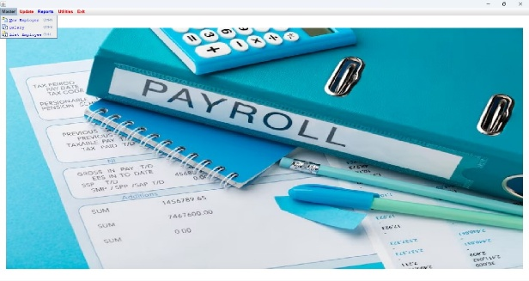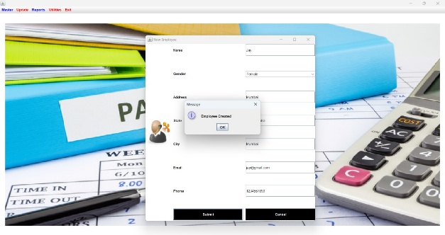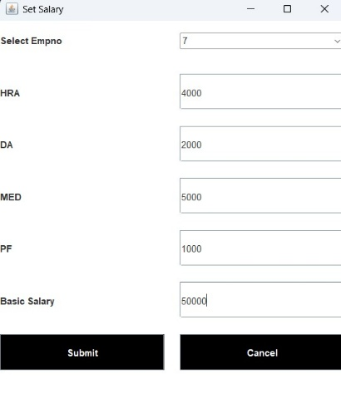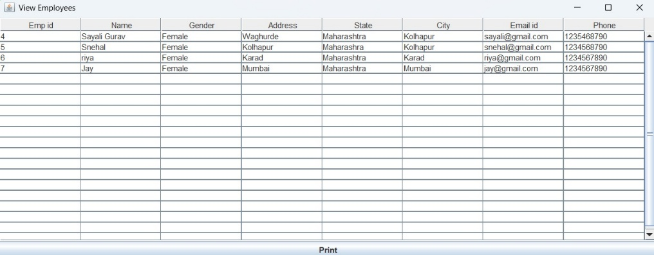

**Group Members:**

|  |  |  |  |
| --- | --- | --- | --- |
| **Unique id** | **Roll No** | **Name of Student** | **Sign** |
| **EN23250711** | **127** | **Snehal Dattatry Kumbhar** |  |
| **EN23103452** | **128** | **Riya Kiran Kamble** |  |
| **EN23208080** | **130** | **Sayali Shankar Gurav** |  |
| **EN23221773** | **135** | **Ankita Ankush Ghunake** |  |